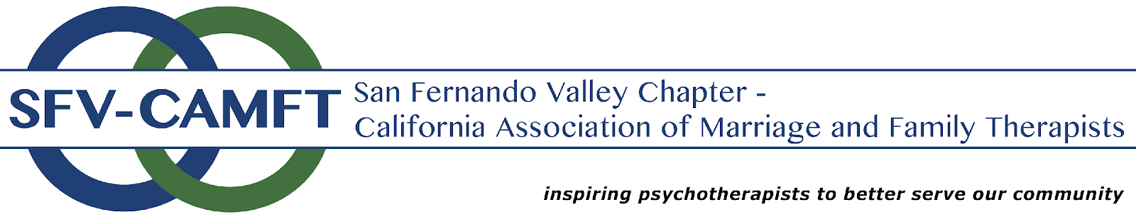

Partnership - Letter of Agreement

This Scholarship Partnership Agreement is between the “Partner” _____________________ and the California Association of Marriage and Family Therapists – San Fernando Valley Chapter (“SFV-CAMFT”) provides the terms and conditions of the “Partnership.”

Partner Representative: ______________________________________________

Partner Address: ____________________________________________________

Partner Email: _______________________________________________________

Partner Phone: _______________________________________________________

Partnership Type/Description: __________________________________________

SFV-CAMFT is proud to able to partner independent of meeting and event sponsorships (i.e. scholarships). Partner representative has applied to partner with SFV-CAMFT and SFV-CAMFT has approved Partner’s participation as provided below.

Upon receipt of signed contract and payment/offering access, SFV-CAMFT will:
- Email partnership offering in at least 3 stand-alone emails that go out to approx. 2800 subscribers (less if members only).
- Offer complimentary admission to 1 membership meeting for 1-2 representatives including breakfast and CE's if attending the entire presentation. If applicable/desired, state which meeting: _________
- Introduction of Partner by Sponsorship Chair.
- One 5-minute segment for to present Partner offering (prior to speaker presentation) in any style i.e. Q&A, PowerPoint, speech, and/or experiential.
- A table/countertop for your resource materials and opportunity to distribute materials on individual member tables.
- Opportunity for meeting attendees to meet your representative.
- Hybrid/virtual meetings: Benefit of additional audience, varying in location, to expand reach. Resource materials will be emailed to participants (may also be put in chat); if any please provided to Sponsorship Chair 2 weeks prior to meeting you choose to attend.
- Bonus: Ability to schedule a tour at your facility with board members after Partnership.
- If applicable, contact Partner representative to state offering conclusion/outcomes. Outline specifics here: __________________________________
- If applicable, email Partnership outcomes to subscribers/members.

Partner will:

- Check which is applicable:
  - ____ Make a payment to SFV-CAMFT, at least (45) days prior to Partnership, in the amount of $__________. An invoice will be sent to you to pay online or you’re able to send money via Zelle: sfvcamftcfo@gmail.com.
  - ____ Provide access to offering prior to Partnership OR within a reasonable time after offering has concluded. Outline specifics here: _______________________

________________________________________________________________

________________________________________________________________

- If attending a meeting:
- Arrive 30 minutes before meeting.
- Provide advertising materials (logo, website, small blurb for introduction, 1 line about services for newsletter) in electronic form at least (30) days prior to meeting date.
- Supply marketing materials (i.e. banner, signage, brochures, promotional items, etc.) for display table and to place on individual member tables, if wanted. If providing digital resources, please send to Sponsorship Chair 2 weeks prior to meeting you choose to attend.
- Speak for one 5-minute segment about partnership services (prior to speaker
- presentation).
- Manage the Partner’s table.
- If applicable, contact Sponsorship Chair to state offering conclusion/outcomes.

If you are in agreement with the above terms and conditions, please sign and date below. A countersigned copy will be returned to you.

_____________________ _____________________
Partnership representative signature Date

_____________________ _____________________
SFV-CAMFT representative signature Date

Questions? Please contact our Sponsorship Chair or President at sfvcamftpre@gmail.com.

